Image to PDF Converter Project Report

Project Title: Image-to-PDF Converter Desktop Application
Developed By: [YAKSH MALASIYA]
Submitted To: [SANDEEP MONGA]
Submission Date: November 2025

This document details the design, implementation, and evaluation of the Image-to-PDF Converter, a lightweight, standalone desktop utility. Developed using Python with the Tkinter library for the Graphical User Interface (GUI), the application’s core purpose is to simplify the aggregation of multiple image files (JPG, PNG) into a single, cohesive PDF document. It offers an intuitive interface, making batch conversion accessible to non-technical users without reliance on commercial software or internet connectivity.
1. 🎯 Problem Statement
The goal is to provide an efficient, offline solution for converting a sequence of digital images into a single PDF document. Current methods are often cumbersome, requiring users to rely on complex printer drivers, proprietary software, or web-based tools that pose privacy risks. This project addresses the need for a reliable, high-performance, and user-friendly desktop application that accurately scales and preserves the aspect ratio of images when placing them onto standard PDF pages.
2. ✅ Functional Requirements
Requirement ID | Description
FR01 | Image Selection: The user must be able to select multiple image files (.jpg, .jpeg, .png) from the local file system.
FR02 | List Display: The selected image filenames must be clearly listed in the application interface.
FR03 | PDF Naming: The user must be able to specify a custom name for the output PDF file.
FR04 | Conversion Core: The application must successfully convert the list of selected images into a single PDF document.
FR05 | Page Structure: Each image must be placed on a separate, full-size page within the PDF.
FR06 | Aspect Preservation: Images must be scaled to fit the page size while strictly maintaining their original aspect ratio to prevent distortion.
FR07 | Output Handling: The application must handle default naming (e.g., output.pdf) if no name is provided.
3. 🔒 Non-functional Requirements
Requirement ID | Description
NFR01 | Usability (UX): The GUI must be simple, clean, and intuitive, requiring minimal user training.
NFR02 | Performance: The conversion process must be completed within a reasonable timeframe (e.g., under 5 seconds for a batch of 10 average-sized images).
NFR03 | Security: Since this is an offline desktop tool, it must not transmit any user data or file information externally.
NFR04 | Portability: The application must run on any operating system (Windows, macOS, Linux) with a Python environment installed.
4. 🏛️ System Architecture
The converter employs a simple, single-tier, monolithic architecture, as the entire process runs client-side.
Structure:
- Presentation Layer (Tkinter): Handles all user interaction, including file selection, list display, and button events.
- Application/Logic Layer (Python): Contains the core class (ImageTOPDFConverter) and methods for orchestrating the process.
- Utility Layer (Pillow & ReportLab):
  - Pillow (PIL): Used to open and read image files and determine their dimensions.
  - ReportLab: Used to create the PDF canvas, draw images, manage pages, and save the final file.
5. 📐 Design Diagrams
Use Case Diagram
The User initiates the process by selecting images, specifying the PDF name, and triggering the conversion.
Workflow Diagram
- Start: Application launches.
- Input: User clicks "Select Images" $\rightarrow$ filedialog opens.
- Process List: Selected file paths are stored, and filenames are displayed in the listbox.
- Convert Trigger: User clicks "Convert to PDF."
- PDF Generation Loop: For each image path:
  - Open image (PIL).
  - Calculate scaling/position.
  - Draw image on PDF canvas (ReportLab).
  - Advance to next page (showPage).
- Output: PDF canvas is saved to the specified output file name.
- End.
Sequence Diagram
Illustrates the calls between the user, the converter object, the file dialog, and the core libraries during a conversion event.
Class/Component Diagram
The primary component is the ImageTOPDFConverter class, which holds methods for initialization, UI management, file selection, and conversion logic.
ER Diagram (if storage used)
Not Applicable: This application does not use persistent storage (like a database or external file system beyond the input/output files) to track state; all data is volatile and stored in memory variables (self.image_paths, self.output_pdf_name).
6. 💡 Design Decisions & Rationale
Decision | Rationale
Tkinter GUI | Chosen as it is a standard library included with most Python distributions, minimizing external dependencies and simplifying deployment.
Pillow (PIL) | Industry standard for Python image manipulation, ensuring wide compatibility with various image formats.
ReportLab | Provides low-level control over PDF canvas elements, necessary for precise image scaling, centering, and guaranteed one-image-per-page placement.
Aspect Ratio Logic | The conversion method includes specific calculation of scale factors to ensure images are fully visible on the page without distortion.
7. 💻 Implementation Details
The application is implemented in a single Python file using an object-oriented approach with the ImageTOPDFConverter class.
- Initialization (__init__): Sets up the main window (root), initializes state variables (image_paths), and configures the UI elements.
- File Selection (select_images): Utilizes tkinter.filedialog.askopenfilenames to securely gather file paths.
- Listbox Update: The update_selected_images_listbox method uses os.path.split to display only the filename, improving readability for the user.
- Conversion (convert_images_to_pdf): This is the core function. It calculates the necessary scaling (scale_factor) to fit the image within the page boundaries (612x792 points, with a 36-point margin) and determines the coordinates (x, y) to center the image on the page before calling pdf.drawInlineImage().
8. 🖼️ Screenshots / Results
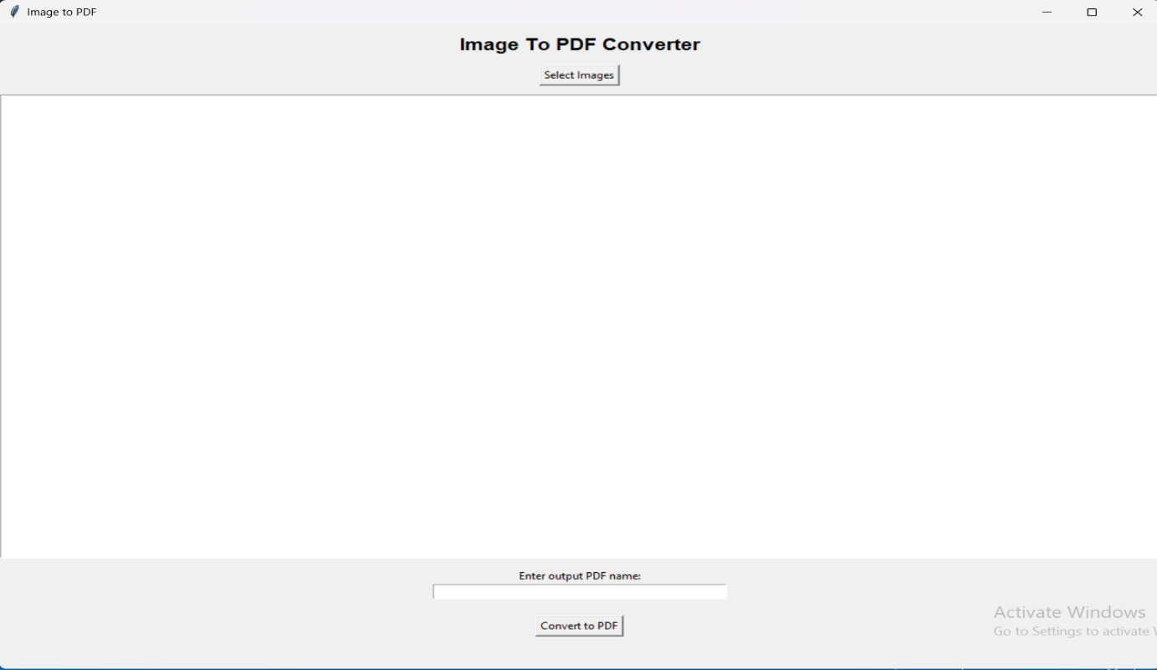
9. 🧪 Testing Approach
The application was tested using primarily Black Box Testing focused on end-user functionality.
Test Case | Steps | Expected Result | Status
TC-01 (Success) | Select 3 JPG images, enter name "Test", click Convert. | A file named Test.pdf is created with 3 pages, images correctly scaled and centered. | Pass
TC-02 (Default Name) | Select 1 PNG image, leave name blank, click Convert. | A file named output.pdf is created with 1 page. | Pass
TC-03 (No Input) | Click "Convert to PDF" with no images selected. | The function returns immediately; no error message or empty PDF file is created. | Pass
TC-04 (Format Check) | Select a mix of JPG and PNG files. | All selected files are successfully processed and included in the PDF. | Pass
10. 🚧 Challenges Faced
- Scaling Complexity: The primary challenge was implementing the robust scaling logic to ensure the image fits the bounds of the ReportLab canvas without being cropped or distorted, which required precise calculation of the scale factor based on both width and height ratios.
- User Feedback: Providing real-time feedback (e.g., a progress bar) during conversion was omitted in the initial version to maintain simplicity, which could be misleading for very large batches. This is noted for future enhancement.
11. 🔑 Learnings & Key Takeaways
The project provided significant experience in integrating disparate Python libraries (tkinter, PIL, reportlab) to deliver a cohesive product. A key takeaway was the difference between designing a UI for web (responsive layout) versus a desktop application (fixed layout management in Tkinter). It reinforced the importance of using low-level libraries like ReportLab when precise control over document layout is required.
12. ✨ Future Enhancements
- Image Reordering: Implement functionality to allow users to drag-and-drop or use up/down buttons to change the sequence of images before conversion.
- PDF Quality Options: Add radio buttons or a dropdown to allow users to select output quality (e.g., "High Resolution" or "Compressed/Web-Optimized").
- Output Directory Selector: Integrate filedialog.askdirectory to allow the user to choose where the final PDF is saved.
14. 📚 References
- Python Tkinter Documentation
- Pillow (PIL) Documentation
- ReportLab User Guide and API Reference
- [Any specific online tutorials or resources used for scaling logic]

